Lab Exercises
Class: 软件1802班 Name: 黎维旺 StuID:___201816040206_____________
Date: 11月12号 Score:
Lab Exercise 1 — Modifying Class Account

I Lab Objectives
In this lab, you will practice:
- Creating member functions.
- Invoking functions and receiving return values from functions.
- Testing a condition using an if statement.
- Outputting variables with stream insertion and the cout object.

II Description of the Problem
Modify class Account to provide a member function called debit that withdraws money from an Account. Ensure that the debit amount does not exceed the Account’s balance. If it does, the balance should be left unchanged and the function should print a message indicating "Debit amount exceeded account balance." Modify class AccountTest to test member function debit.

III Sample Output
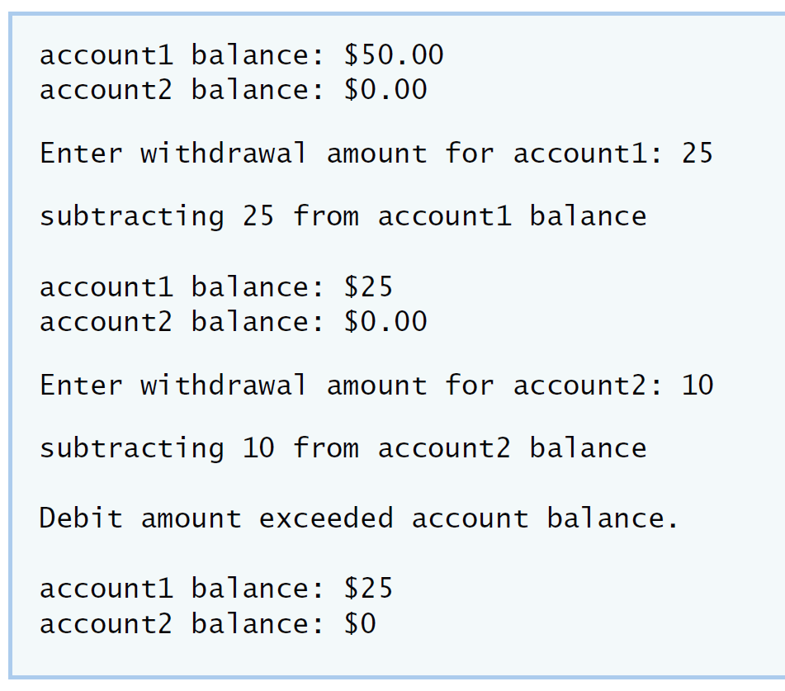
IV Your Solution

// Lab 1: Account.h
// Definition of Account class.

class Account
{
public:
Account( int ); // constructor initializes balance
void credit( int ); // add an amount to the account balance
/* write code to declare member function debit. */
void debit(int);
int getBalance(); // return the account balance
private:
int balance; // data member that stores the balance
}; // end class Account
// Lab 1: Account.cpp
// Member-function definitions for class Account.
#include <iostream>
using namespace std;

#include "Account.h" // include definition of class Account

// Account constructor initializes data member balance
Account::Account( int initialBalance )
{
balance = 0; // assume that the balance begins at 0

// if initialBalance is greater than 0, set this value as the
// balance of the Account; otherwise, balance remains 0
if ( initialBalance > 0 )
balance = initialBalance;

// if initialBalance is negative, print error message
if ( initialBalance < 0 )
cout << "Error: Initial balance cannot be negative.\n" << endl;
} // end Account constructor

// credit (add) an amount to the account balance
void Account::credit( int amount )
{
balance = balance + amount; // add amount to balance
} // end function credit

/* write code to define member function debit. */
void Account::debit(int amount)
{
if(amount<=balance)
balance=balance-amount;
else
cout <<"Debit amount exceeded account balance."<< endl;
}
// return the account balance
int Account::getBalance()
{
return balance; // gives the value of balance to the calling function
} // end function getBalance
// Lab 1: AccountTest.cpp
// Create and manipulate Account objects.
#include <iostream>
using namespace std;

// include definition of class Account from Account.h
#include "Account.h"

// function main begins program execution
int main()
{
Account account1( 50 ); // create Account object
Account account2( 0 ); // create Account object

// display initial balance of each object
cout << "account1 balance: $" << account1.getBalance() << endl;
cout << "account2 balance: $" << account2.getBalance() << endl;

int withdrawalAmount; // stores withdrawal amount read from user

cout << "\nEnter withdrawal amount for account1: "; // prompt
cin >> withdrawalAmount; // obtain user input
cout << "\nsubtracting " << withdrawalAmount
<< " from account1 balance\n\n";
/* write code to withdraw money from account1 */
account1.debit(withdrawalAmount);
// display balances
cout << "account1 balance: $" << account1.getBalance() << endl;
cout << "account2 balance: $" << account2.getBalance() << endl;

cout << "\nEnter withdrawal amount for account2: "; // prompt
cin >> withdrawalAmount; // obtain user input
cout << "\nsubtracting " << withdrawalAmount
<< " from account2 balance\n\n";
/* write code to withdraw money from account2 */
account2.debit(withdrawalAmount);
// display balances
cout << "account1 balance: $" << account1.getBalance() << endl;
cout << "account2 balance: $" << account2.getBalance() << endl;
} // end main

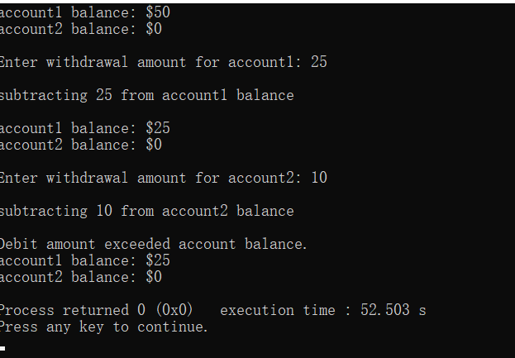
Lab Exercise 2 — Modifying class GradeBook

I Lab Objectives
In this lab, you will practice:
- Declaring a data member.
- Providing set and get functions to manipulate a data member’s value.
- Declaring member functions with parameters.

II Description of the Problem
Modify class GradeBook. Include a second string data member that represents the name of the course’s instructor. Provide a set function to change the instructor’s name and a get function to retrieve it. Modify the constructor to specify two parameters—one for the course name and one for the instructor’s name. Modify member function displayMessage such that it first outputs the welcome message and course name, then outputs "This course is presented by: " followed by the instructor’s name. Modify the test application to demonstrate the class’s new capabilities.

III Sample Output
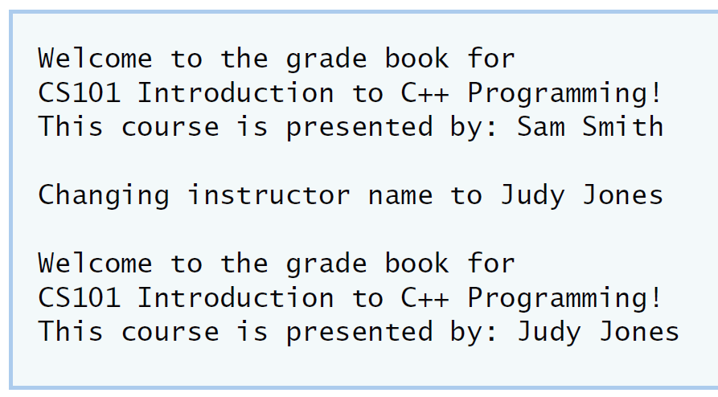
IV Your Solution
// Lab 2: GradeBook.h
// Definition of GradeBook class that stores an instructor's name.
#include <string> // program uses C++ standard string class
using namespace std;

// GradeBook class definition
class GradeBook
{
public:
// constructor initializes course name and instructor name
GradeBook( string, string );
void setCourseName( string ); // function to set the course name
string getCourseName(); // function to retrieve the course name
void setName(string );
string getName();
/* write code to declare a get function for the instructor's name */
/* write code to declare a set function for the instructor's name */
void displayMessage(); // display welcome message and instructor name
private:
string courseName; // course name for this GradeBook
string instructorName; // instructor name for this GradeBook
}; // end class GradeBook

// Lab 2: GradeBook.cpp
// Member-function definitions for class GradeBook.
#include <iostream>
using namespace std;

// include definition of class GradeBook from GradeBook.h
#include "GradeBook.h"

// constructor initializes courseName and instructorName
// with strings supplied as arguments
GradeBook::GradeBook( string course, string instructor )
{
setCourseName( course ); // initializes courseName
setInstructorName( instructor ); // initialiZes instructorName
} // end GradeBook constructor

// function to set the course name
void GradeBook::setCourseName( string name )
{
courseName = name; // store the course name
} // end function setCourseName

// function to retrieve the course name
string GradeBook::getCourseName()
{
return courseName;
} // end function getCourseName

void GradeBook::setName(string name)
{
getName = name;
}

string GradeBook::getName(string name)
{
return Name;
}
/* write code to define a get member function for the instructor's name */

/* write code to define a set member function for the instructor's name */

// display a welcome message and the instructor's name
void GradeBook::displayMessage()
{
// display a welcome message containing the course name
cout << "Welcome to the grade book for\n" << getCourseName() << "!"
<< endl;
cout << "This course is presented by: Sam Smith"<< getName)() <<"!"
<< endl;
/* write code to output the instructor's name */
} // end function displayMessage
// Lab 2: GradeBookTest.cpp
// Test program for modified GradeBook class.
#include <iostream>
using namespace std;

// include definition of class GradeBook from GradeBook.h
#include "GradeBook.h"

// function main begins program execution
int main()
{
// create a GradeBook object; pass a course name and instructor name
GradeBook gradeBook(
"CS101 Introduction to C++ Programming" );

// display welcome message and instructor's name
gradeBook.displayMessage();

/* write code to change instructor's name and output changes */
} // end main

Lab Exercise 3 — Creating an Employee Class

I Lab Objectives
In this lab, you will practice:
- Creating a class definition.
- Declaring data members.
- Defining a constructor.
- Defining set and get functions.
- Writing a test application to demonstrate the capabilities of another class.

II Description of the Problem
Create a class called Employee that includes three pieces of information as data members—a first name (type string), a last name (type string) and a monthly salary (type int). Your class should have a constructor that initializes the three data members. Provide a set and a get function for each data member. If the monthly salary is not positive, set it to 0. Write a test program that demonstrates class Employee’s capabilities. Create two Employee objects and display each object’s yearly salary. Then give each Employee a 10 percent raise and display each Employee’s yearly salary again.

III Sample Output
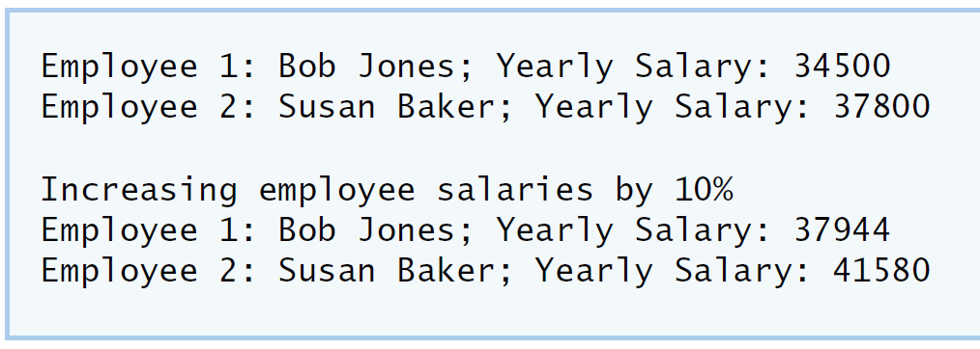
IV Your Solution
Lab Exercise 4 — Complex Numbers

I Lab Objectives
In this lab, you will practice:
- Creating new data types by writing class definitions.
- Defining member functions of programmer-defined classes.
- Instantiating objects from programmer-defined classes.
- Calling member functions of programmer-defined classes.
The follow-up questions and activities will also give you practice:
- Initializing programmer-defined class data members with class constructors.

II Description of the Problem
Create a class called Complex for performing arithmetic with complex numbers. Write a program to test your class.
Complex numbers have the form：
realPart + imaginaryPart * i
where i is
$$\sqrt{-1}$$
Use double variables to represent the private data of the class. Provide a constructor that enables an object of this class to be initialized when it is declared. The constructor should contain default values in case no initializers are provided. Provide public member functions that perform the following tasks:
1) Adding two Complex numbers: The real parts are added together and the imaginary parts are added together.
2) Subtracting two Complex numbers: The real part of the right operand is subtracted from the real part of the left operand and the imaginary part of the right operand is subtracted from the imaginary part of the left operand.
3) Printing Complex numbers in the form (a, b) where a is the real part and b is the imaginary part.

III Sample Output
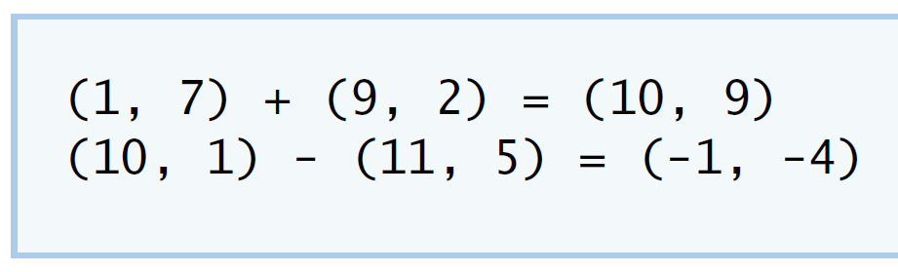

IV Your Solution
// Lab 4: Complex.h
#ifndef COMPLEX_H
#define COMPLEX_H
class Complex
{
public:
Complex( double = 0, double = 0);
void printComplex();
void setComplexNumber( double, double);
Complex add(const Complex &right);
Complex subtract( const Complex &right );
private:
double realPart;
double imaginaryPart;
};
/* Write class definition for Complex */

#endif

// Lab 4: Complex.cpp
// Member-function definitions for class Complex.
#include <iostream>
using namespace std;

#include "Complex.h"

Complex::Complex( double real, double imaginary )
{
setComplexNumber( real, imaginary );
} // end Complex constructor

Complex Complex::add( const Complex &right )
{
realPart += right.realPart;
imaginaryPart += right.imaginaryPart;
return *this;
/* Write a statement to return a Complex object. Add
the realPart of right to the realPart of this Complex
object and add the imaginaryPart of right to the
imaginaryPart of this Complex object */
} // end function add

Complex Complex::subtract( const Complex &right )
{
realPart -= right.realPart;
imaginaryPart -= right.imaginaryPart;
return *this;

/* Write a statement to return a Complex object. Subtract
the realPart of right from the realPart of this Complex
object and subtract the imaginaryPart of right from
the imaginaryPart of this Complex object */
} // end function subtract

void Complex::printComplex()
{
cout << '(' << realPart << ", " << imaginaryPart << ')';
} // end function printComplex

void Complex::setComplexNumber( double rp, double ip )
{
realPart = rp;
imaginaryPart = ip;
} // end function setComplexNumber
// Lab 4: ComplexTest.cpp
#include <iostream>
using namespace std;

#include "Complex.h"

int main()
{
Complex a( 1, 7 ), b( 9, 2 ), c; // create three Complex objects

a.printComplex(); // output object a
cout << " + ";
b.printComplex(); // output object b
cout << " = ";
c = a.add( b ); // invoke add function and assign to object c
c.printComplex(); // output object c

cout << '\n';
a.setComplexNumber( 10, 1 ); // reset realPart and
b.setComplexNumber( 11, 5 ); // and imaginaryPart
a.printComplex(); // output object a
cout << " - ";
b.printComplex(); // output object b
cout << " = ";
c = a.subtract( b ); // invoke add function and assign to object c
c.printComplex(); // output object c
cout << endl;
} // end main
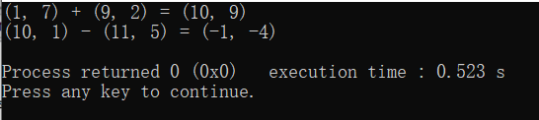

V Follow-Up Questions and Activities
- Why do you think const was used in the parameter list of add and subtract?
- Can add and subtract’s parameters be passed by value instead of by reference? How might this affect the design of class Complex? Write a new class definition that illustrates how the parameters would be passed by value.
- Declare a Complex number, as follows, without passing any arguments to the constructor. What happens?Does the default constructor get called?
Complex a;
Lab Exercise 5 — Dates

I Lab Objectives
In this lab, you will practice:
- Using access functions and utility functions so that it is not necessary for non-member functions to be able to access a class’ data members.
The follow-up questions and activities also will give you practice:
- Overloading constructors and using default arguments with constructors.
- Defining a destructor.

II Description of the Problem
Modify the Date class to provide a member function nextDay to increment the day by one. The Date object should always remain in a consistent state. Write a program that tests function nextDay in a loop that prints the date during each iteration to illustrate that the nextDay function works correctly. Be sure to test the following cases:
- Incrementing into the next month.
- Incrementing into the next year.

III Sample Output
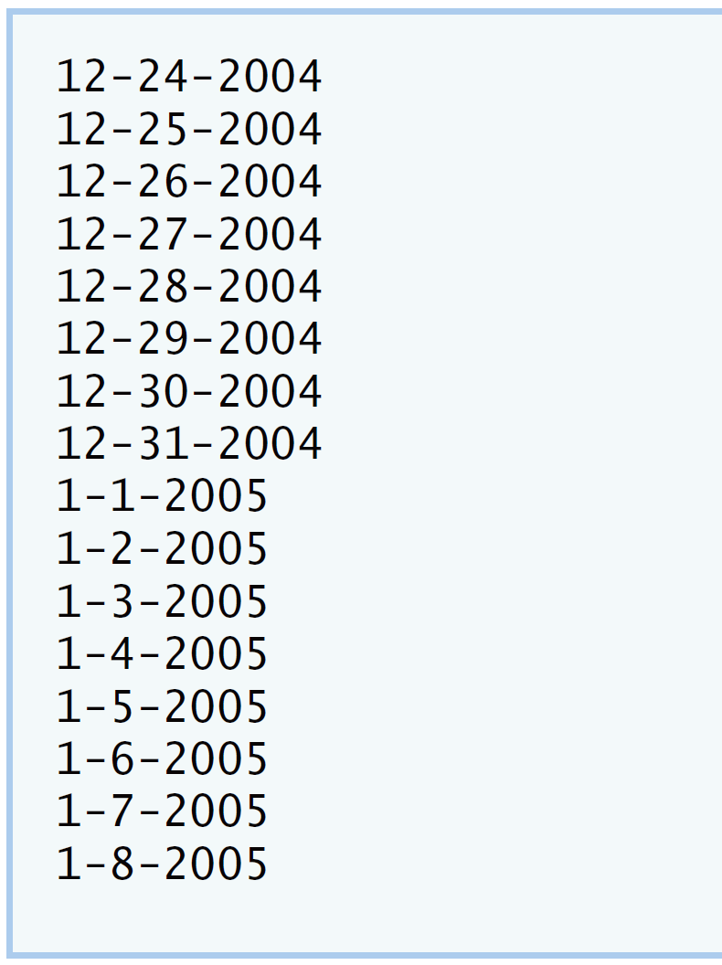

IV Your Solution
// Lab 5: Date.h
#ifndef DATE_H
#define DATE_H

class Date
{
public:
Date( int = 1, int = 1, int = 2000 ); // default constructor
void print(); // print function
void setDate( int, int, int ); // set month, day, year
void setMonth( int ); // set month
void setDay( int ); // set day
void setYear( int ); // set year
int getMonth(); // get month
int getDay(); // get day
int getYear(); // get year
void nextDay();
/* Write a member function prototype for nextDay,
which will increment the Date by one day */
private:
int month; // 1-12
int day; // 1-31 (except February(leap year), April, June, Sept, Nov)
int year; // 1900+
bool leapYear(); // leap year
int monthDays(); // days in month
}; // end class Date

#endif
// Lab 5: Date.cpp
// Member-function definitions for class Date.
#include <iostream>
using namespace std;

#include "Date.h" // include definition of class Date

Date::Date( int m, int d, int y )
{
setDate( m, d, y ); // sets date
} // end Date constructor

void Date::setDate( int mo, int dy, int yr )
{
setMonth( mo ); // invokes function setMonth
setDay( dy ); // invokes function setDay
setYear( yr ); // invokes function setYear
} // end function setDate

void Date::setDay( int d )
{
if ( month == 2 && leapYear() )
day = ( d <= 29 && d >= 1 ) ? d : 1;
else
day = ( d <= monthDays() && d >= 1 ) ? d : 1;
} // end function setDay

void Date::setMonth( int m )
{
month = m <= 12 && m >= 1 ? m : 1; // sets month
} // end function setMonth

void Date::setYear( int y )
{
year = y >= 1900 ? y : 1900; // sets year
} // end function setYear

int Date::getDay()
{
return day;
} // end function getDay

int Date::getMonth()
{
return month;
} // end function getMonth

int Date::getYear()
{
return year;
} // end function getYear

void Date::print()
{
cout << month << '-' << day << '-' << year << '\n'; // outputs date
} // end function print

/* Write code to define member function nextDay;
make sure to check if the new day is the start of
a new month or a new year */
void Date::nextDay()
{
day++;
if(day > monthDays())
{
day = 1;
month++;
}
if(month > 12)
{
month = 1;
year++;
}

// if(month == 1 && day == 1)
// year++;
}

bool Date::leapYear()
{
if ( getYear() % 400 == 0 || ( getYear() % 4 == 0 && getYear() % 100 != 0 ) )
return true; // is a leap year
else
return false; // is not a leap year
} // end function leapYear

int Date::monthDays()
{
const int days[ 12 ] =
{ 31, 28, 31, 30, 31, 30, 31, 31, 30, 31, 30, 31 };

return getMonth() == 2 && leapYear() ? 29 : days[ getMonth() - 1 ];
} // end function monthDays
// Lab 5: DateTest.cpp
#include <iostream>
using namespace std;

#include "Date.h" // include definitions of class Date

int main()
{
const int MAXDAYS = 16;
Date d( 12, 24, 2004 ); // instantiate object d of class Date

// output Date object d's value
for ( int loop = 1; loop <= MAXDAYS; ++loop )
{
d.print(); // invokes function print
d.nextDay();

/* Write call to nextDay */
} // end for

cout << endl;
} // end main

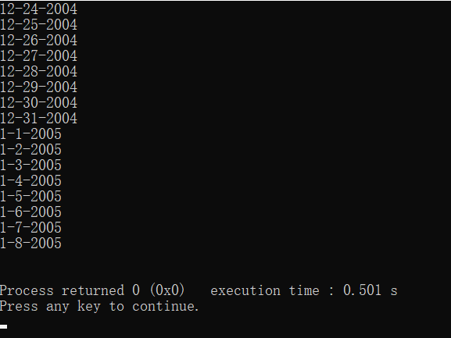
V Follow-Up Questions and Activities
- The Date class has only one constructor. Is it possible to have more than one constructor?
- What happens when a member function that takes no arguments is called without the parentheses (i.e.,dateObject.nextDay)?
- Write a destructor for the Date class. The destructor should print text indicating that the destructor for the Date class was called successfully.
- In main, try to change d’s year to 2003 using an assignment statement. Do not call function setYear. What happens? Are you able to change the value?

Lab Exercise 6 — Simple Calculator

I Lab Objectives
In this lab, you will practice:
- Using classes to create a data type Simple Calculator capable of performing arithmetic operations.
- Creating const member functions to enforce the principle of least privilege.
The follow-up questions and activities also will give you practice:
- Using constructors to specify initial values for data members of a programmer-defined class.

II Description of the Problem
Write a SimpleCalculator class that has public methods for adding, subtracting, multiplying and dividing two doubles. A sample call is as follows:
double answer = sc.add( a, b );
Object sc is of type SimpleCalculator. Member function add returns the result of adding its two arguments.

III Sample Output
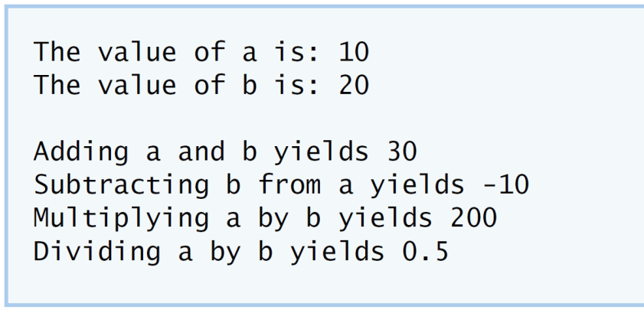

IV Your Solution
// Lab Exercise 6: SimpleCalculator.h

// class SimpleCalculator definition
class SimpleCalculator
{
public:
/* Write prototype for add member function */
double add(double, double) const;
double subtract( double, double ) const;
double multiply( double, double ) const;
double divide(double, double ) const;
/* Write prototype for divide member function */
}; // end class SimpleCalculator

// Lab Exercise 6: SimpleCalculator.cpp

#include "SimpleCalculator.h"

/* Write definition for add member function */
double SimpleCalculator::add(double a, double b) const
{
return a + b;
}

// function subtract definition
double SimpleCalculator::subtract( double a, double b ) const
{
return a - b;
} // end function subtract

// function multiply definition
double SimpleCalculator::multiply( double a, double b ) const
{
return a * b;
} // end function multiply

/* Write definition for divide member function */
double SimpleCalculator::divide(double a, double b) const
{
return a/b;
}

// Lab Exercise 6: CalcTest.cpp

#include <iostream>
using namespace std;

#include "SimpleCalculator.h"

int main()
{

double a = 10.0;
double b = 20.0;

/* Instantiate an object of type Simplecalculator */
SimpleCalculator sc;

cout << "The value of a is: " << a << "\n";
cout << "The value of b is: " << b << "\n\n";
double addition = sc.add(a, b);
/* Write a line that adds a and b through your SimpleCalculator
object; assign the result to a variable named addition */

cout << "Adding a and b yields " << addition << "\n";

double subtraction = sc.subtract( a, b );
cout << "Subtracting b from a yields " << subtraction << "\n";

double multiplication = sc.multiply( a, b );
cout << "Multiplying a by b yields " << multiplication << "\n";
double division = sc.divide(a, b);
/* Write a line that divides a and b through the
SimpleCalculator object; assign the result to a
variable named division */
cout << "Dividing a by b yields " << division << endl;
}

V Follow-Up Questions and Activities
- Why doesn’t the SimpleCalculator class have a constructor?
- Why are no private data members needed for class SimpleCalculator?
- Modify your class so that SimpleCalculator has a private data member called answer. After performing an operation, assign the result to answer. Add a member function named getAnswer to retrieve the result of the last arithmetic operation performed by the object. Also, add a constructor for class SimpleCalculator that initializes the value of answer to 0.
- Modify the program so that the SimpleCalculator class has an input member function that allows the user to input two doubles. The function should then store the values that were input in private data members. Use these two values for each of the arithmetic calculations. Create two constructors for this class, one that takes no arguments and initializes a and b to 0 and another that takes two doubles and initializes a and b to those values. Finally, create a member function printValues that displays the values of a and b. A segment of the driver program might now look like this:
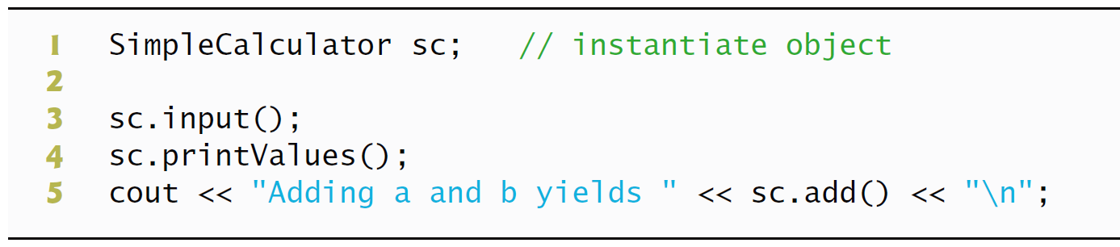

*Lab Exercise 7 — Integer Set

I Lab Objectives
In this lab, you will practice:
- Using classes to create a data type, IntegerSet, capable of storing a set of integers
- Using dynamic memory allocation with the new and delete operators
The follow-up questions and activities also will give you practice:
- Using destructors to deallocate memory that was dynamically allocated.

II Description of the Problem
Create class IntegerSet for which each object can hold integers in the range 0 through 100. A set is represented internally as an array of ones and zeros. Array element a[ i ] is 1 if integer i is in the set. Array element a[ j ] is 0 if integer j is not in the set. The default constructor initializes a set to the so-called “empty-set,” i.e., a set whose array representation contains all zeros.
Provide member functions for the common set operations. For example, a unionOfSets member function (already provided) creates a third set that is the set-theoretic union of two existing sets (i.e., an element of the third array’s is set to 1 if that element is 1 in either or both of the existing sets, and an element of the third set’s array is set to 0 if that element is 0 in each of the existing sets).
Provide an intersectionOfSets member function which creates a third set which is the set-theoretic intersection of two existing sets (i.e., an element of the third set’s array is set to 0 if that element is 0 in either or both of the existing sets, and an element of the third set’s array is set to 1 if that element is 1 in each of the existing sets).
An insertElement member function (already provided) inserts a new integer k into a set (by setting a[ k ] to 1 ). Provide a deleteElement member function that deletes integer m (by setting a[ m ] to 0 ).
A printSet member function (already provided) prints a set as a list of numbers separated by spaces. Print only those elements which are present in the set (i.e., their position in the array has a value of 1 ). Print --- for an empty set.
Provide an isEqualTo member function that determines whether two sets are equal.
Provide an additional constructor that receives an array of integers and the size of that array and uses the array to initialize a set object.
Now write a driver program to test your IntegerSet class. Instantiate several IntegerSet objects. Test that all your member functions work properly.

III Sample Output
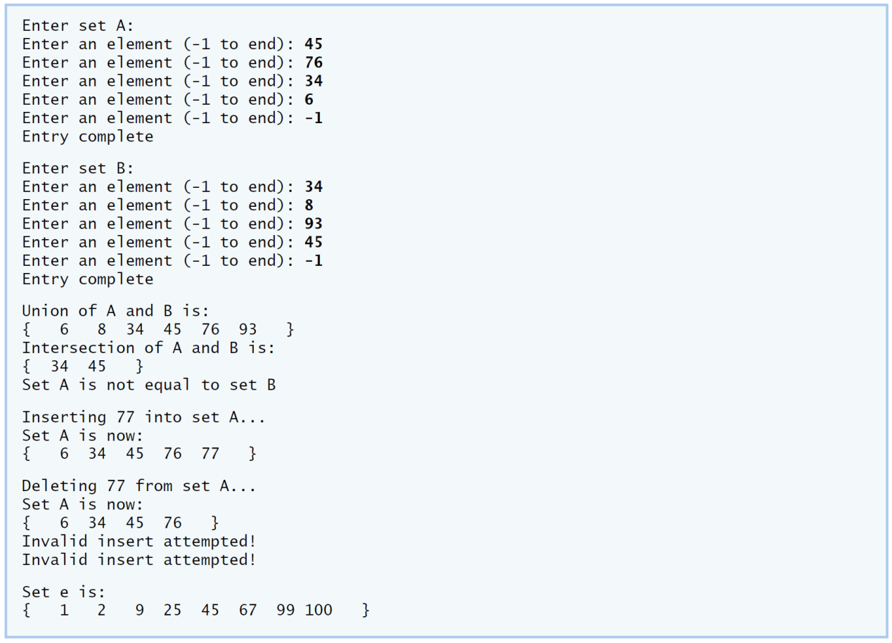
IV Your Solution

V Follow-Up Questions and Activities
- Why might it be advantageous for the set array to be allocated dynamically using new [], if the IntegerSet class were to be used for more general sets?

